Use Case Table

Title: | Driver Creates a group trip
Description: | The Driver will either login and choose a created group to setup a trip with or will create an account and group of friends they want to make a trip with.
Primary Actor: | In this case the main user is the driver who would set up a trip with his friends.
Preconditions: | User makes an account
Postconditions: | Driver has reached their destination with their friends and gets a review of
Main  Success Scenario: | - Driver creates an account/logs in to account  - Driver adds friends  - Driver creates a group with friends  - Chooses group and configures route settings  - Sets destination  - Pickup friends on the way to destination  - Reach destination  - Review trip
Extensions: | The use case can also be used by one of the riders in the same steps as the main scenario.
Frequency of Use: | This will be the main use case being used by the driver whenever they set a trip.

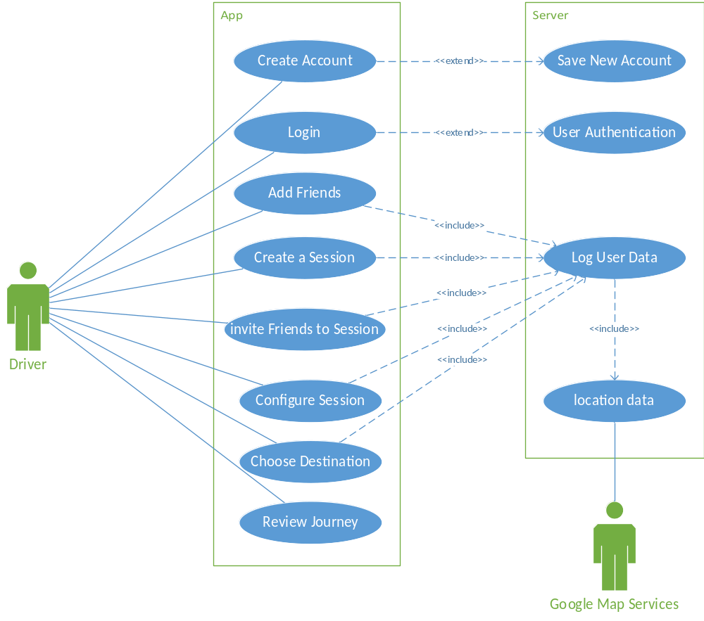
Use Case Diagram

